 | Assignment -4
 | Docker and Kubernetes
Assignment Date |  | 21 October 2022
Team ID |  | PNT2022TMID23493
Maximum Marks |  | 2 Marks

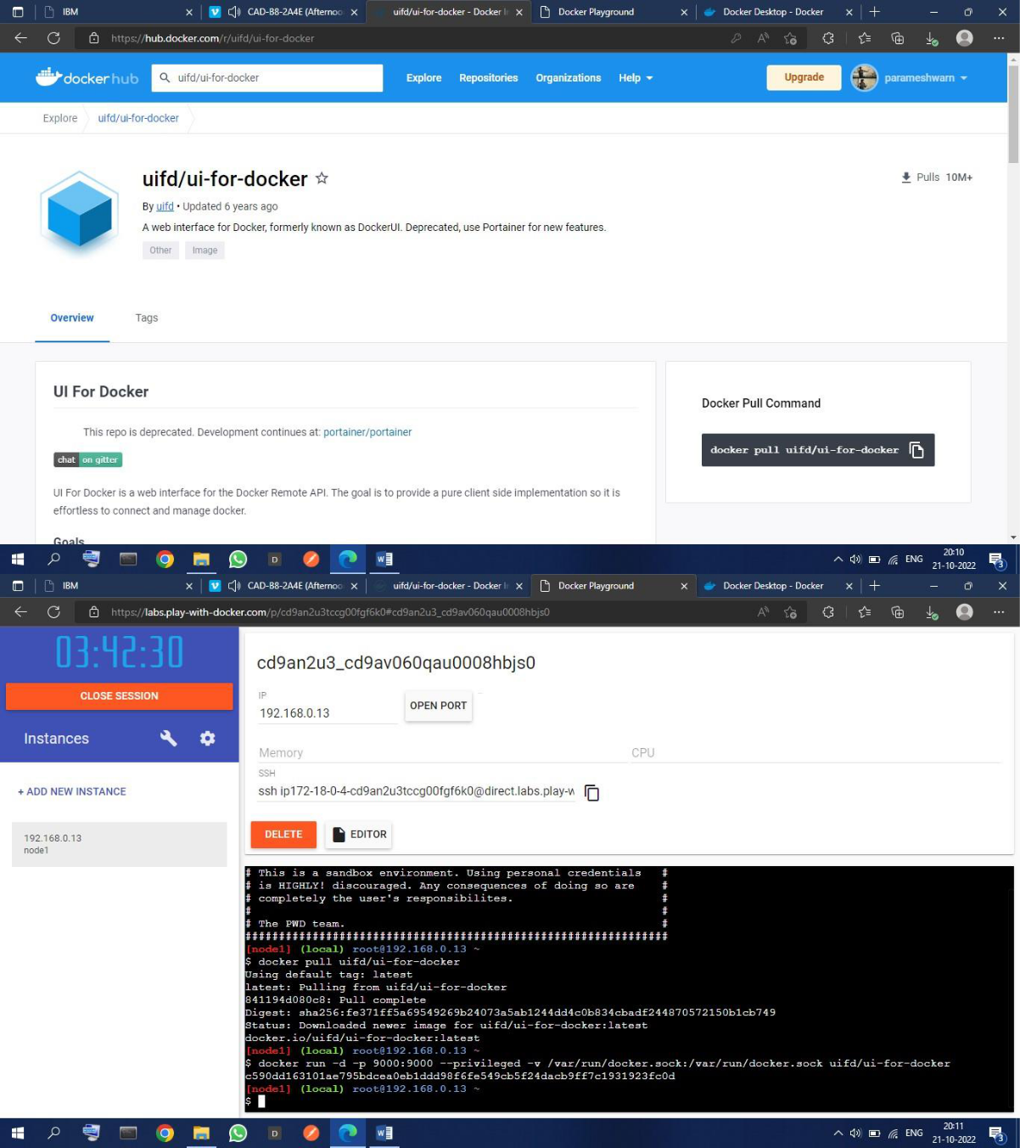
1.Pull an image from docker hub and run it in docker Playground

2.Create a docker file for the job portal application and deploy it in Docker desktop application

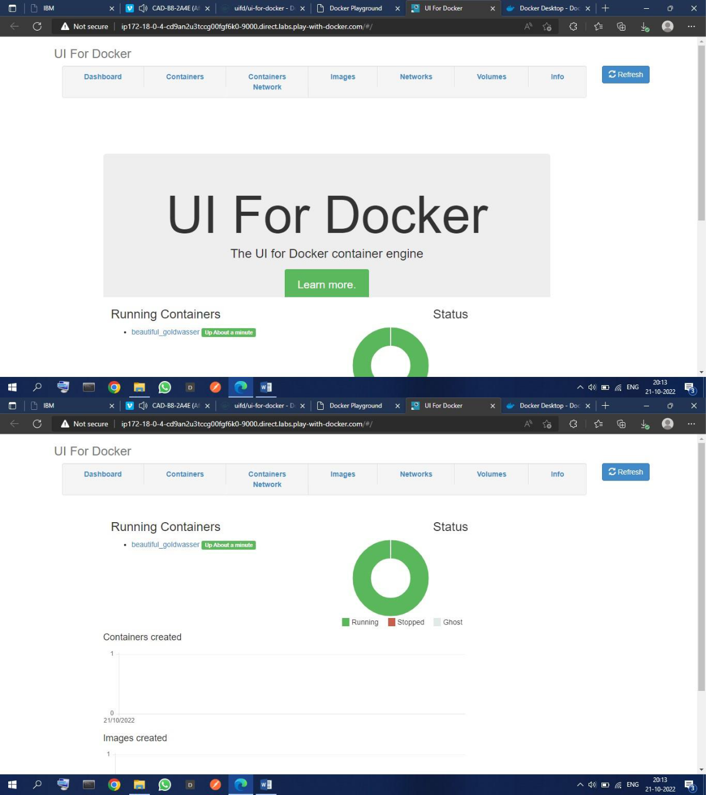
3.Create a IBM container registry and deploy hello word app

